Irresistible Peanut Butter Cookies

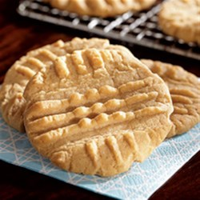
Ingredients
- 1 1/4 cups firmly packed light brown sugar
- 3/4 cup JIF(R) Peanut Butter
- 1/2 cup Butter Flavor CRISCO Stick
- 3 tablespoons milk
- 1 tablespoon vanilla
- 1 egg
- 1 3/4 cups sifted all-purpose flour
- 3/4 teaspoon baking soda
- 3/4 teaspoon salt

Directions
- Preheat oven to 375 degrees F. Place sheets of foil on countertop for cooling cookies.
- Combine brown sugar, JIF(R) peanut butter, shortening, milk and vanilla in large bowl. Beat at medium speed of electric mixer until well blended. Add egg. Beat just until blended.
- Combine flour, baking soda and salt. Add to creamed mixture at low speed. Mix just until blended.
- Drop by rounded tablespoonfuls 2 inches apart onto ungreased cookie sheet. Flatten slightly in crisscross pattern with tines of fork.
- Bake one baking sheet at a time for 7-8 minutes or until set and just beginning to brown. Do not over-bake. Cool 2 minutes on baking sheet. Remove cookies to foil to cool completely.

